1. **Input two numbers find the sum of their squares. If the sum of their squares is greater than 100, print the two numbers. Otherwise print the sum of their squares.**

**Code:**

import java.util.Scanner;

public class Main {

public static void main(String[] args) {

int a, b, sum;

Scanner sc = new Scanner (System.in);

a = sc.nextInt ();

b = sc.nextInt ();

sum = a * a + b * b;

if (sum > 100)

System.out.print (a + " " + b);

else

System.out.print (sum);

}

}

**Output:**

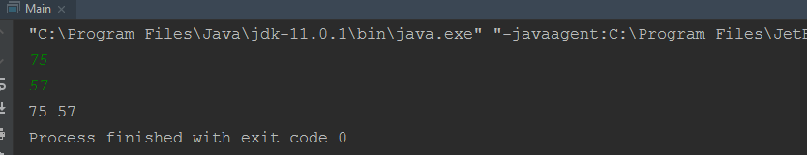

1. **A company manufactures two product A & B. It gives a discount of 5% on A if orders for A exceed Rs. 5000 and 7% on B if the orders for B exceed Rs. 10000, otherwise no discount. Write a program to print to input order amount of A & B and print the discounts for each product.**

**Code:**

import java.util.Scanner;

public class Main {

public static void main (String[] args) {

int A, B, discount1, discount2;

Scanner sc = new Scanner (System.in);

A = sc.nextInt ();

B = sc.nextInt ();

if (A>5000) {

discount1 = (A * 5) / 100;

System.out.println (discount1);

}

else

System.out.println ("no discount");

if (B>10000) {

discount2 = (B * 7) / 100;

System.out.println (discount2);

}

else

System.out.println ("no discount");

}

}

**Output:**

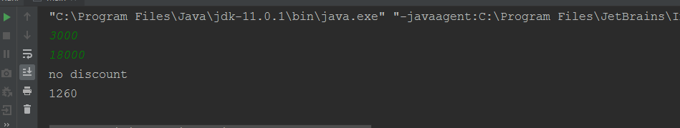

1. **Print numbers 11 to 100 with 10 numbers in a row.**

**Code:**

public class Main {

public static void main (String[] args) {

int i;

for (i =11;i<=100;i++) {

if (i % 10 == 0)

System.out.println (i);

else

System.out.print (i + " ");

}

}

}

**Output:**

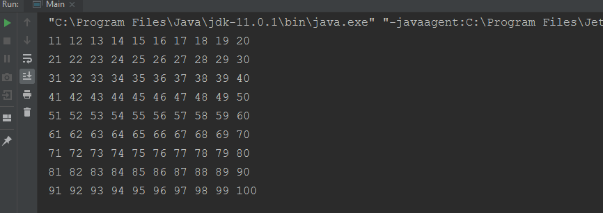

1. **A company pays its employees on a “piece-work” basis. The company produces three products. The “piece-rate” for the items is Rs. 1.20, Rs. 1.80 and Rs. 2.25 respectively. Read from the input unit employee number, units of products 1, 2 and 3 respectively. Calculate the wages and print employee number and gross wages of each employee. The employee number Zero indicates the end of data.**

**Code:**

import java.util.Scanner;

public class Main {

public static void main (String[] args) {

Scanner sc=new Scanner (System.in);

int n=sc.nextInt();

int empno[]=new int[n];

double gs[]=new double[n];

int i=0;

while(i<n)

{

System.out.println ("enter the employee number :");

empno [i] = sc.nextInt ();

if (empno[i] == 0)

break;

else {

System.out.println ("enter no.of product '1' manufactured by" + empno[i]);

int n1 = sc.nextInt();

System.out.println ("enter no.of product '2' manufactured by" + empno[i]);

int n2 = sc.nextInt();

System.out.println ("enter no.of product '3' manufactured by" + empno[i]);

double gsa = n1 * 1.2 + n2 * 1.8 + n3 * 2.25;

gs[i] = gsa;

i++;

}

}

for(int j=0;j<i;j++)

{

System.out.println (empno[j]+" "+gs[j]);

}

}

}

**Output:**

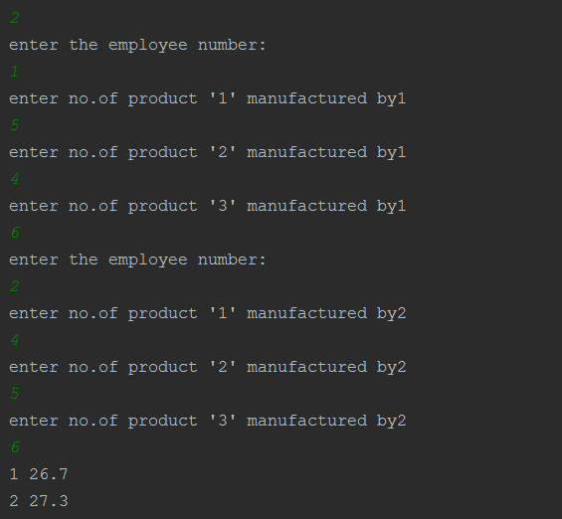

1. **Write a program to check whether given number is prime number.**

**Code:**

import java.util.Scanner;

public class Main {

public static void main (String[] args) {

int n, i, count=0;

Scanner sc= new Scanner (System.in);

n= sc.nextInt ();

for (i=1; i<=n; i++)

{

if (n % i==0)

{

count++;

}

}

if (count==2)

System.out.print (n+ " is prime number");

else

System.out.print (n+ " is not prime number");

}

}

**Output:**

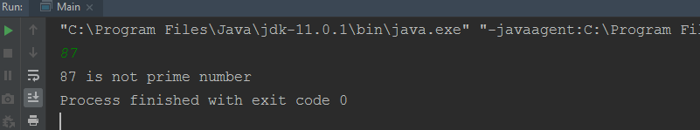

1. **Write a program to calculate and print the sum S and product P of 1,2,3,4……n.**

**Code:**

import java.util.Scanner;

public class Main {

public static void main (String[] args) {

int n, i, sum=0, product=1;

Scanner sc= new Scanner (System.in);

n= sc.nextInt ();

for (i=1; i<=n; i++) {

sum = sum + i;

product = product * i;

}

System.out.println (sum);

System.out.print (product);

}

}

**Output:**

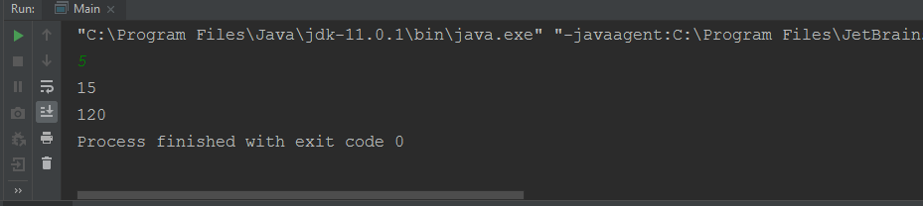

1. **Calculate Factorial of N = 1*2*3*4…..n. and print the same along with the number.**

**The output should be:**

**The factorial of the number <no_entered> is <factorial_calculated>**

**Code:**

import java.util.Scanner;

public class Main {

public static void main (String[] args) {

int n, i, factorial=1;

Scanner sc= new Scanner (System.in);

n= sc.nextInt ();

for (i=1; i<=n; i++) {

factorial = factorial * i;

}

System.out.print ("The factorial of a number " +n+ " is " +factorial);

}

}

**Output:**

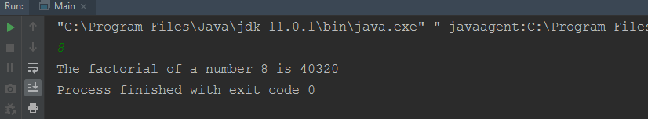

1. **Write a program to find the sum 1^2 + 2^3 + 3^4 ….. N^ n+1.**

**Code:**

import java.util.Scanner;

import java.lang.Math;

public class Main {

Public static void main (String [] args) {

int n, i, sum = 0;

Scanner sc = new Scanner (System.in);

n = sc.nextInt ();

for (i = 1; i <= n; i++) {

sum += Math.pow (i, i+1);

}

System.out.print (sum);

}

}

**Output:**

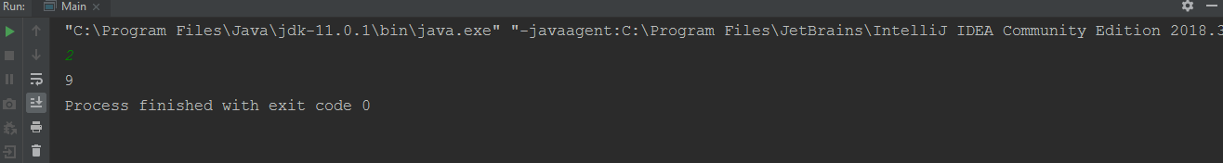

1. **Find the sum and product of 10 input numbers.**

**Code:**

import java.util.Scanner;

public class Main {

public static void main (String[] args) {

int n, i, sum = 0, product = 1;

Scanner sc = new Scanner (System.in);

n = sc.nextInt ();

for (i = 1; i <= 10; i++) {

sum = sum + i;

product = product * i;

}

System.out.println (sum);

System.out.print (product);

}

}

**Output:**

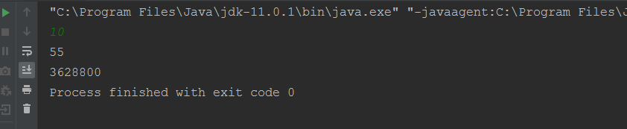

1. **An organization has collected data for 200 sales orders during last one day. The record includes data items of : CUST NO, PROD NO, QTY and RATE. Accept the records one by one to compute sales value and then print all details in one line per record. Also print total sales value at the end.**

**Code:**

import java.util.Scanner;

class sales{

public static void main(String args[]){

Scanner s=new Scanner(System.in);

int[] id=new int[200];

int[] p_no=new int[200];

String[] qty=new String[200];

double[] rte=new double[200];

double sum=0;

for(int i=0;i<10;i++){

id[i]=s.nextInt();

p_no[i]=s.nextInt();

qty[i]=s.next();

rte[i]=s.nextDouble ();

}

System.out.println("Customer Id\tProduct Id\tQuality\tRate");

for(int i=0;i<10;i++){

System.out.print(id[i]+"\t\t\t\t"+p_no[i]+"\t\t" +qty[i]+"\t"+rte[i]);

System.out.println("");

sum+=rte[i];

}

System.out.println("Total sales value:"+sum);

}

}

**Output:**

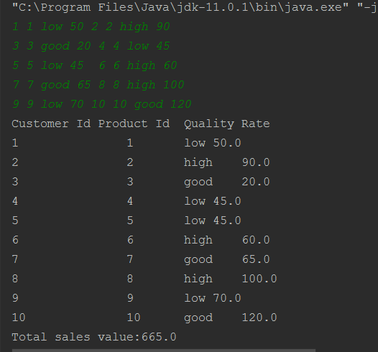

**11.Given names and hours worked in a month by 10 employees. Each employee is paid at an hourly rate of Rs. 4.50. If the Gross Salary is greater than Rs. 720/- an employee gets an additional incentive of 5% of Gross Salary. Generate a report to print all employee details (Name, Hours Worked, Gross Salary , Incentive).**

**At the end of report print total incentive paid, total gross salary and how many employees getting incentive.**

**Code:**

class gross{

public void print(String name,int hrs){

System.out.print (name+"\t"+hrs+"\t");

double Inc=0,salary=hrs*4.5;

if(salary>720)

Inc=5;

salary+=(Inc/100)*100;

System.out.println ( salary+"\t\t"+Inc);

}

public static void main(String args[]){

gross g=new gross();

System.out.println ("Name\tHours Salary\tInective");

g.print ("shekhar",180);

g.print ("kalyani",150);

g.print ("sunny",200);

g.print ("sohita",120);

g.print ("bhavya",140);

g.print ("sanju",160);

g.print ("hrudai",100);

g.print ("bhanu",190);

g.print ("krishna",120);

g.print ("roopa",90);

}

}

**Output:**

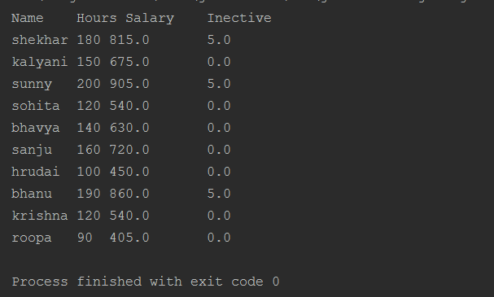

**12. Input ‘N’ values of X, one at a time, find and print the number of positive values; the number of zero values and the number of negative values.**

**Code:**

import java.util.Scanner;

public class Main {

public static void main(String[] args) {

int n;

int pos_count=0 , i, neg_count=0,zero_count=0;

Scanner sc = new Scanner (System.in);

n = sc.nextInt ();

int a[] = new int[n];

for(i=0;i<n;i++)

a[i]=sc.nextInt ();

for (i=0;i<n;i++) {

if (a[i] > 0)

pos_count++;

else if (a[i] < 0) {

neg_count++;

} else {

zero_count++;

}

}

System.out.println ("positive count is: " +pos_count);

System.out.println ("negative count is: " +neg_count);

System.out.print ("zero count is: " +zero_count);

}

}

Output:

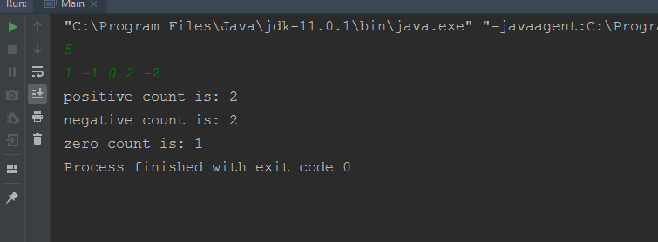

**13. Accept the marks of 100 students and find the number of students who have passed and the**

**number of those who have failed.**

**Code:**

import java.util.Scanner;

public class Main {

public static void main(String[] args) {

int i, pass = 0, fail = 0;

Scanner sc= new Scanner (System.in);

int a[]= new int[100];

for(i=0;i<100;i++)

a[i]=sc.nextInt();

for(i=0;i<100;i++){

if(a[i]>45){

pass++;

}

else{

fail++;

}

}

System.out.println("passed students are: " +pass);

System.out.print("failed students are: " +fail);

}

}

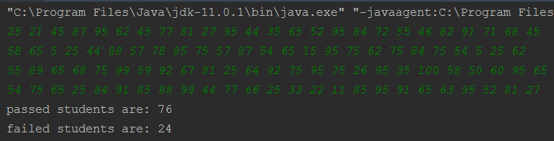**Output:**

**14. Accept the marks of n students and find the number and percentage of students getting first class, second-class, pass class and failing.**

**Code:**

import java.util.Scanner;

public class Main {

public static void main(String[] args) {

int n, i, first=0,second=0, pass = 0, fail = 0;

Scanner sc= new Scanner (System.in);

n=sc.nextInt ();

int a[]= new int[n];

for (i=0;i<n;i++)

a[i]=sc.nextInt();

for (i=0;i<a.length;i++)

{

If (a[i]>80 && a[i]<=100)

{

first++;

}

else if(a[i]>60 && a[i]<=80)

second ++;

else if(a[i]>=45 && a[i]<=60)

pass++;

else

fail++;

}

System.out.println ("percentage of students getting first class is: " + first*100/n);

System.out.println ("percentage of students getting second class is: " +second*100/n);

System.out.println ("percentage of students getting pass class is: " +pass*100/n);

System.out.print ("percentage of students getting fail is: " +fail*100/n);

}

}

**Output:**

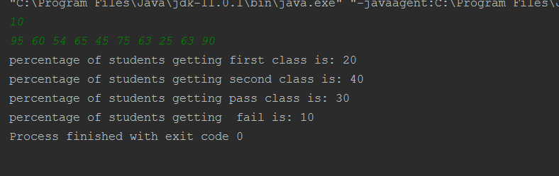

**15. Suppose the population of countries A &amp; B are 60 and 90 million respectively and the rate of population growth for A &amp; B are 5.8% and 4.2 respectively per year. Write a program to print the population of A &amp; B each year until the population of A exceeds that of B and also print the number of years for the population of A to exceed the population of B.**

**Code:**

public class Main {

public static void main (String[] args) {

double A = 60, B = 90;

int year=0;

while (A<B)

{

A=A*((5.8)/100);

B=B*((4.2)/100);

year ++;

}

System.out.print (year+ "years of A population exceeds B population");

}

}

**Output:**

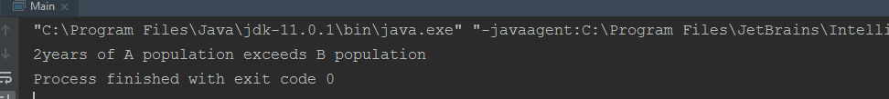

**16. Find the smallest of 100 given positive numbers.**

**Code:**

import java.util.Scanner;

public class Main {

public static void main(String[] args) {

int i, smallest=0;

Scanner sc= new Scanner (System.in);

int a[]=new int[100];

for (i=0;i<100;i++)

a [i]=sc.nextInt();

smallest =a[0];

for (i=0;i<a.length;i++)

{

If (a[i]<smallest)

{

Smallest =a[i];

}

}

System.out.println (smallest);

}

}

**Output:**

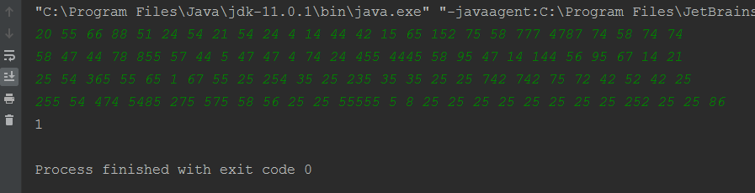

**17. Find the largest of N positive numbers.**

**Code:**

import java.util.Scanner;

public class Main {

public static void main(String[] args) {

int n, i, largest=0;

Scanner sc= new Scanner (System.in);

n=sc.nextInt ();

int a[]=new int[n];

for (i=0;i<n; i++)

a[i]=sc.nextInt();

largest =a[0];

for (i=0;i<a.length;i++) {

if(a[i]>largest)

{

largest=a[i];

}

}

System.out.println (largest);

}

}

**Output:**

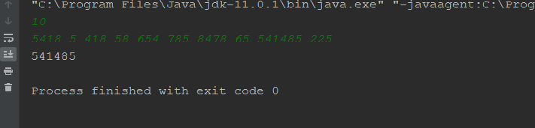

**18. Accept 100 positive numbers, one at a time and find the smallest and the greatest of the 100 given numbers and print them together with the range of the 100 numbers. (range = (the greatest) – (the smallest))**

**Code:**

import java.util.Scanner;

public class Main {

public static void main (String[] args) {

Scanner sc= new Scanner (System.in);

int a []= new int[100];

for (int i=0;i<100;i++)

{

a [i]=sc.nextInt();

}

int greatest=a[0],smallest=a[0];

for (int i=0;i<100;i++)

{

If (a[i]>greatest)

greatest =a[i];

if (a[i]<smallest)

smallest =a[i];

}

int range=greatest-smallest;

System.out.println ("Greatest: " +greatest);

System.out.println ("Smallest: " +smallest);

System.out.println ("Range: " +range);

}

}

**Output:**

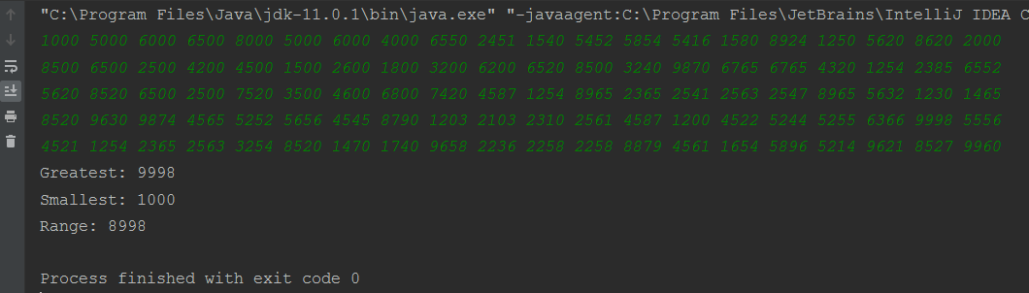

**19. Accept n Salesman numbers and total weekly sales in Rupees by them. End of data is indicated by**

**a dummy entry in which salesman number is zero. Find out the salesman number who has the**

**highest and lowest weekly sales and the amount of the highest weekly sales and the lowest weekly**

**sales.**

**Code:**

import java.util.Scanner;

public class Main {

public static void main(String[] args) {

Scanner s=new Scanner (System.in);

int[] s_id=new int[3];

int[] w_sal=new int[3];

int t=0;

for(int i=0;i<3;i++){

s_id[i]= s.nextInt ();

w_sal[i]=s.nextInt();

t++;

if(s_id[i]==0)

break;

}

int lar = w_sal[0],sml = w_sal[0];

int l=0,sm=0;

for (int i=0;i<t;i++) {

if (w_sal[i]>lar) {

lar = w_sal[i];

l=i;

}

}

for (int i=0;i<t;i++){

if (w_sal[i]<sml){

sml=w_sal[i];

sm=i;

}

}

System.out.println("salesman id for highest weekly sales is:"+s_id[l]);

System.out.println("salesman id for lowest weekly sales is:"+s_id[sm]);

System.out.println("highest amount of weekly salesman is:"+lar);

System.out.println("small amount of weekly salesman is:"+sml);

}

}

**Output:**

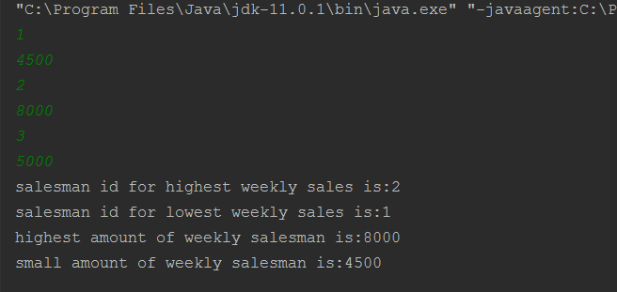

**20. Write a program to read the Roll number, Name and the marks obtained in 3 subjects for the**

**students of an institute. End of data is indicated by Roll no=0. Print with suitable headings :**

**(a) The Mark list providing complete details of each student.**

**(b) The highest marks in each subject and the Name of the student who gets it and**

**(c) The highest average and the corresponding Name of the Student.**

**The result is to be determined as follows:**

**Fail : if less than 35 marks in any subject**

**Pass Class : if Avg >=35 but < 45**

**Second Class: if Avg >=45 but < 60**

**First Class : if Avg >=60 but < 75**

**Distinction : if Avg >=75**

**Code:**

package com.internshala.javaapp;

import java.util.Scanner;

public class Main {

public static void main(String[] args) {

Scanner s=new Scanner(System.in);

int n=s.nextInt();

String[] names=new String[n];

String[] grade=new String[5];

int t=0;

int[] r_no=new int[n];

int[] sub1=new int[n];

int[] sub2=new int[n];

int[] sub3=new int[n];

double[] avg=new double[n];

for(int i=0;i<n;i++){

r_no[i]=s.nextInt();

names[i]=s.next();

sub1[i]=s.nextInt();

sub2[i]=s.nextInt();

sub3[i]=s.nextInt();

t++;

if(r_no[i]==0)

break;

}

for(int i=0;i<t;i++)

avg[i]=(sub1[i]+sub2[i]+sub3[i])/3;

System.out.println("Rollno \tNames \tsub1 \tsub2 \tsub3 \tAverage \tGrade");

for(int i=0;i<t;i++){

if(avg[i]>=75)

grade[i]="Distinction";

else if(avg[i]>=60&&avg[i]<75)

grade[i]="First class";

else if(avg[i]>=45&&avg[i]<60)

grade[i]="Second class";

else if(avg[i]>=35&&avg[i]<45)

grade[i]="Third class";

else

grade[i]="Fail";

System.out.println(r_no[i]+" \t"+names[i]+" \t"+sub1[i]+" \t"+sub2[i]+" \t"+sub3[i]+" \t"+avg[i]+" \t"+grade[i]+" \t");

}

int s1=sub1[0],s2=sub2[0],s3=sub3[0],f=0,se=0,th=0;

double av=avg[0];

int av1=0;

int i;

for (i=0;i<sub1.length;i++) {

if (s1 < sub1[i]) {

s1 = sub1[i];

f = i;

}

}

for (i=0;i<sub2.length;i++) {

if (s2 < sub2[i]) {

s2 = sub2[i];

se = i;

}

}

s3=sub3[0];

for (i=0;i<sub3.length;i++)

{

if (s3 <sub3[i]) {

s3 = sub3[i];

th = i;

}

}

for (i=0;i<avg.length;i++) {

if (av < avg[i]) {

av = avg[i];

av1 = i;

}

}

System.out.println(names[f]+" got highest marks in subject 1 : "+sub1[f]);

System.out.println(names[se]+" got highest marks in subject 2 : "+sub2[se]);

System.out.println(names[th]+" got highest marks in subject 3 : "+sub3[th]);

System.out.println(names[av1]+" got highest Average : "+avg[av1]);

}

}

**Output:**

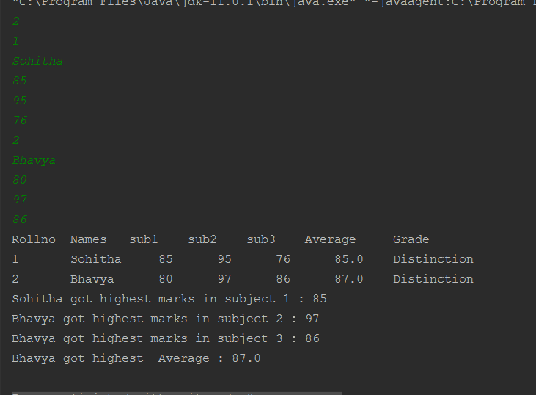

**21. A survey of 100 students was conducted. For each student the input is Sex (Female or Male) and**

**status (Continued and or Dropouts). Find and print with appropriate title the percentage of**

**female dropouts an the percentage of male dropouts.**

**Code:**

import java.util.Scanner;

public class Main {

public static void main(String[] args) {

Scanner s=new Scanner (System.in);

char[] gen=new char[100];

char[] sta=new char[100];

double t=0,st=0;

double p1,p2;

System.out.println ("enter the student gender(F/M) and Status(C/D):");

for(int i=0;i<100;i++){

gen[i]=s.next().charAt(0);

sta[i]=s.next().charAt(0);

}

for(int i=0;i<100;i++){

if(gen[i]=='F'&&sta[i]=='D')

t++;

if(gen[i]=='M'&&sta[i]=='D')

st++;

}

p1=(t/100)*100;

p2=(st/100)*100;

System.out.println(" Female dropouts percentage \tMale droupouts percentage");

System.out.print(p1+"\t\t\t\t");

System.out.print(p2);

}

}

**Output:**

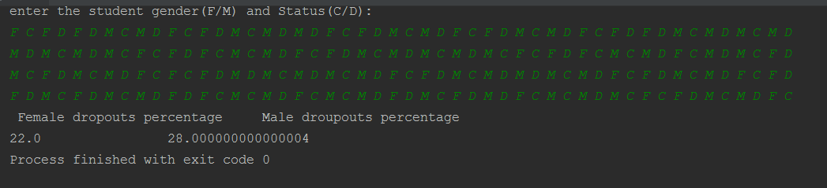

**22. To calculate the commission payable to the salesman based on the total monthly sales. For the**

**first Rs. 10,000/- of sales, commission is NIL. For the next Rs. 20,000/- at 2.5%. For the next Rs.**

**20,000/- at 5%. For the next Rs. 30,000/- at 7.5%. For the excess at 10%.**

**Code:**

import java.util.Scanner;

class AddNumbers{

public static void main(String args[]){

int m,c=0;

System.out.println ("Monthly sales (in Rs.):");

Scanner in = new Scanner (System.in);

m = in.nextInt();

//m=100000

if(m>=10000){m=m-10000;}else{System.out.println("Commission = " + c);System.exit(1);}

if(m>=20000){m=m-20000;c+=(2.5*20000)/100;}else{System.out.println("Commission = " + c);System.exit(1);}

if(m>=20000){m=m-20000;c+=(5*20000)/100;}else{System.out.println("Commission = " + c);System.exit(1);}

if(m>=30000){m=m-30000;c+=(7.5*30000)/100;}else{System.out.println("Commission = " + c);System.exit(1);}

if(m>0){c+=(0.1*m);}else{System.out.println("Commission = " + c);}System.exit (1);

}

}

**Output:**

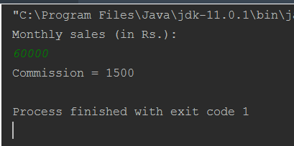

**24. Wage Calculations for 10 employee**

**Weekly wages are based on hours of work are as follows:**

**On first 40 hours, Rs. 10 per hour.**

**On next 20 house, Rs. 15 per hour.**

**Remaining hours, Rs. 20 per hour.**

**Based on hours of work, wages are to be calculated as per above schedule. Printing to be done in 5 columns, hours, part of wages at 10 Rs. per hour, at 15 Rs. per hour, at 20 Rs. per hour and total wages. Appropriate headings are to be given to each column and the total of wages in each column are also to be printed.**

**Code:**

import java.util.Scanner;

class wages{

public static void main(String args[]) {

int h,w1=0,w2=0,w3=0,t=0,h_d;

System.out.println("Total hrs: ");

Scanner in = new Scanner(System.in);

h = in.nextInt();h_d=h;

System.out.println("-------------------------------------------------\n");

System.out.println("hrs\tRs.10/hr\tRs.15/hr\tRs.20/hr\tTotal\n");

System.out.println("-------------------------------------------------\n");

if(h>=40){h=h-40;w1=(10*40);t+=w1;System.out.println(40+"\t\t"+w1+"\t\t\t"+0+"\t\t\t"+0+"\t\t\t"+w1);}else{w1=(h*10);t+=w1;System.out.println(h+"\t\t"+w1+"\t\t\t"+0+"\t\t\t"+0+"\t\t\t"+w1);}

if(h>=20){h=h-20;w2=(15*20);t+=w2;System.out.println(20+"\t\t"+0+"\t\t\t"+w2+"\t\t\t"+0+"\t\t\t"+w2);}else{w2=(h*15);t+=w2;System.out.println(h+"\t\t"+0+"\t\t\t"+w2+"\t\t\t"+0+"\t\t\t"+w2);}

if(h>=0){w3=(h*20);t+=w3;System.out.println(h+"\t\t"+0+"\t\t\t"+0+"\t\t\t"+w3+"\t\t\t"+w3);}

System.out.println ("-------------------------------------------------\n");

System.out.println (h_d+"\t\t"+w1+"\t\t\t"+w2+"\t\t\t"+w3+"\t\t\t"+t);

System.out.println ("-------------------------------------------------\n");

System.exit(1);

}

}

**Output:**

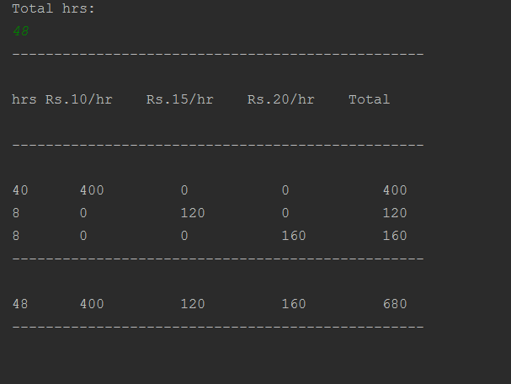

**25. A bank has the following policy on deposits. If the amount of the deposit is Rs. 5000 or above and**

**for 3 years and above interest is 12%. On deposit of Rs. 5000 and above for less than 3 years**

**interest rate is 10%. On deposits below Rs. 5000 regardless of the period interest rate is 9%.**

**Write a program to input A/C number, Name, Amount of deposit and years. Print all account**

**details along with maturity amount for 100 A/C holders.**

**Code:**

import java.util.Scanner;

class bank {

public void print(long acc, String name, int amt , int year){

double d1=0,d2,d3;

System.out.print (acc+" \t"+name+" \t"+amt+"\t"+year+"\t");

if(amt>5000&&year>3)

d1=12;

else if(amt>5000&&year<3)

d1=10;

else if(amt<5000)

d1=9;

d2=(d1/100);

d3=amt*d2*year;

System.out.println(d3);

}

public static void main(String args[]){

Scanner s=new Scanner(System.in);

bank b=new bank();

System.out.println("ACCOUNT NUMBER\tNAME\t\tAMOUNT\tYEAR\tMATURITY AMOUNT");

b.print(12345678,"shekhar",5500,4);

b.print(12345679,"kalyani",4800,3);

b.print(12345680,"chitti",4900,2);

b.print(12345681,"chinni",5800,4);

}

}

**Output:**

